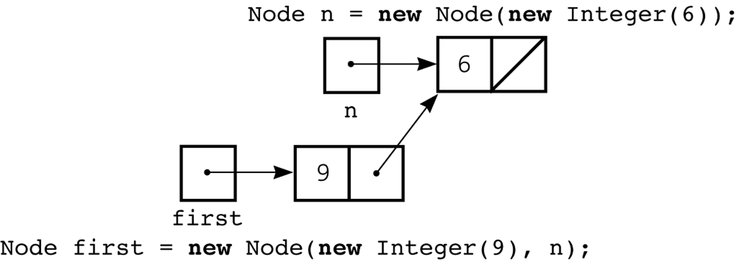

public class Node {
private Object item;
private Node next;

public Node(Object newItem) {
item = newItem;
next = null;
} // end constructor

public Node(Object newItem, Node nextNode) {
item = newItem;
next = nextNode;
} // end constructor

public void setItem(Object newItem) {
item = newItem;
} // end setItem

public Object getItem() {
return item;
} // end getItem

public void setNext(Node nextNode) {
next = nextNode;
} // end setNext

public Node getNext() {
return next;
} // end getNext
} // end class Node

